Chapter -1
Introduction

The rapid proliferation of electric vehicles (EVs) has underscored the urgent need for a robust charging infrastructure. As the global transition towards sustainable transportation accelerates, the demand for efficient and accessible EV charging solutions is paramount. This growing demand is not only driven by the increasing sales of EVs but also by supportive policies and consumer preferences favoring renewable energy sources for charging.
To meet this demand, it is essential to integrate both renewable and non-renewable power generation methods. The combination of solar energy, energy storage systems (ESS), and grid power can significantly enhance the efficiency of power supply to DC fast charging and battery swapping stations. By optimizing this integration, we can achieve substantial cost savings while ensuring a reliable energy supply that meets fluctuating charging demands.

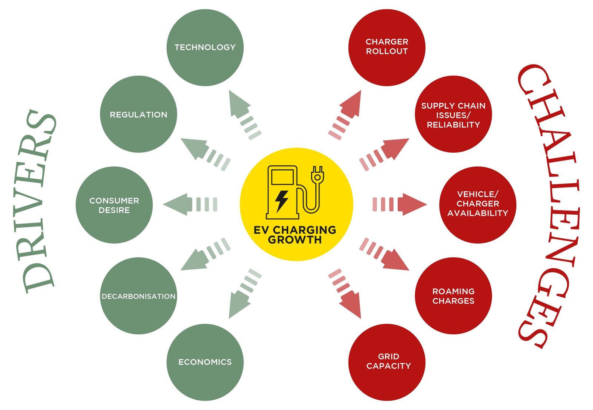

Fig 1 : EV Charging Drivers and Challenges

The proposed Internet of Things (IoT) architecture plays a critical role in this context by facilitating real-time monitoring and data collection from various sensors deployed throughout the charging infrastructure. This architecture enables remote visualization and enhances end-user connectivity, allowing users to access vital information regarding charging status, energy consumption, and availability. By leveraging predictive analytics, the system can optimize power demand management, ensuring that resources are utilized efficiently.

By utilizing real-time data monitoring, the IoT architecture allows for the optimization of power demand and battery management. This leads to improved overall efficiency in EV charging operations, as systems can dynamically adjust to changing energy needs and usage patterns. The integration of predictive analytics within the IoT framework can result in substantial cost savings. The architecture facilitates the seamless integration of renewable energy sources, such as solar power and energy storage systems (ESS), with grid power. This not only promotes sustainable practices but also enhances the reliability of power supply at charging stations.
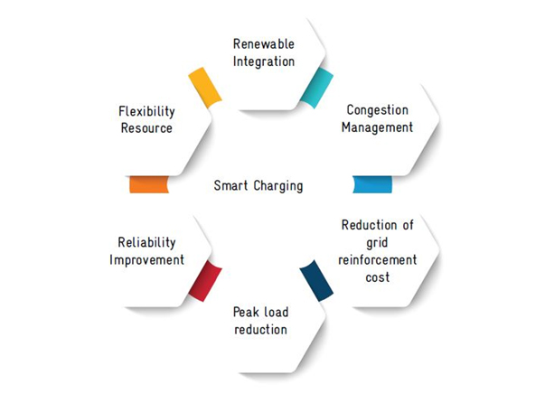
Fig 2 : Smart charging
The project proposed system enables remote access to charging status, energy consumption data, and operational metrics through a user-friendly interface. This capability enhances user engagement and allows operators to make informed decisions based on real-time insights. The IoT architecture is designed to be scalable, allowing businesses to expand their charging infrastructure in response to growing demand. This adaptability is crucial for meeting the evolving needs of consumers and the market.
The Continuous data collection from sensors provides valuable insights into customer behavior and operational performance. This information can be leveraged to identify trends, improve services, and enhance customer satisfaction. Support for Smart City Initiatives: By integrating with broader smart city frameworks, the IoT architecture contributes to the development of connected EV charging networks, promoting investments in sustainable infrastructure and enhancing urban mobility solutions.
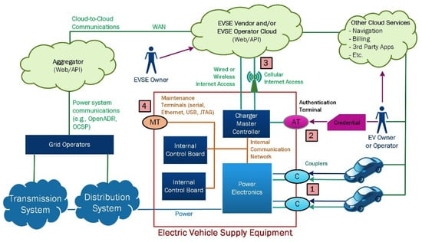
Fig 3 : Charging infra IOT integration
Predictive analytics within the IoT architecture for electric vehicle charging operations offers significant benefits that enhance both efficiency and user experience. By leveraging historical data and usage patterns, predictive analytics enable the forecasting of energy demand, allowing charging stations to proactively manage power requirements. This capability ensures that sufficient energy is available during peak usage times while minimizing costs during off-peak periods. Furthermore, predictive analytics optimize charging schedules by analyzing factors such as battery state-of-charge (SOC) and the availability of renewable energy sources. This results in more efficient charging processes, reducing energy waste and enhancing overall operational efficiency.
In addition to improving efficiency, predictive analytics contributes to substantial cost savings—potentially reducing operational expenses by up to 90%—by minimizing reliance on expensive grid power during peak hours and maximizing the use of renewable energy. It also enhances maintenance and reliability by identifying potential equipment failures before they occur, allowing for proactive maintenance scheduling that reduces downtime. User engagement is another critical advantage; real-time information about charging status and availability fosters better customer experience, leading to increased satisfaction and loyalty.
The scalability and adaptability provided by predictive analytics are essential as EV adoption continues to grow. This flexibility allows charging infrastructure to expand without compromising service quality. Ultimately, the insights gained from predictive analytics empower operators to make informed decisions regarding pricing strategies, resource allocation, and infrastructure investments, creating a more sustainable and efficient EV charging ecosystem.

